

|  |
| --- |
| **Website Development** |
| Year 11 Information Processes and Technology |
|  |
|  |





Contents

Understanding the problem 3

**Aims and objectives of the website** 3

**How the website will support Pittwater House to meet its own goals** 3

**Data and information needed for website** 3

**Information processes used** 3

**Information Technology to be utilized** 4

**Ethical and Social Issues** 5

Making Decisions 6

Schedule Feasibility 6

Justification of the Gantt Chart 7

Understanding the problem 7

Making Decisions 7

Designing solutions 7

Implementing 7

Testing 8

Designing Solutions 9

Designs and storyboard for the website 9

Designs and storyboard for the digital media 13

Implementing 15

Implementation of Website 15

Implementation of Wow Factor 19

Testing, Evaluating and Maintenance 20

Testing 20

Reflection 21

Future maintenance 21

## Understanding the problem

### **Aims and objectives of the website**

The objective of the website is to educate the Year 11 IPT students about Chapter 11, “The Internet”, in the Year 11 IPT. The website needs to have a good layout and color theme so that it would not irrigate the eyes. Content on the website should be easy to read and understand. The navigation should clear and easily accessible from any of the pages. The website should be appropriate for all ages.

### **How the website will support Pittwater House to meet its own goals**

The website is going to help Pittwater House by proving teaching and revision material on Year 11 IPT Textbook Chapter 11 “The internet”.

### **Data and information needed for website**

The data and information are needed for the website are the information from the Year 11 IPT textbook from Chapter 11, “The Internet”, and relevant information on the “Internet” topic which is gathered using the research.

### **Information processes used**

* **Collecting** – Information on “The Internet” topic and any relevant information have to be collected.
* **Organizing** – The files are going to organized in such a way for easy to read and function eg. root folder containing subfolders for different files and scripts.
* **Storing and retrieving** – The date would be stored on hosting company’s server aswell as backup on GitHub and locally on my computer.
* **Transmitting and receiving** – As the client request a webpage from the server, the server would send the required webpage via the internet.

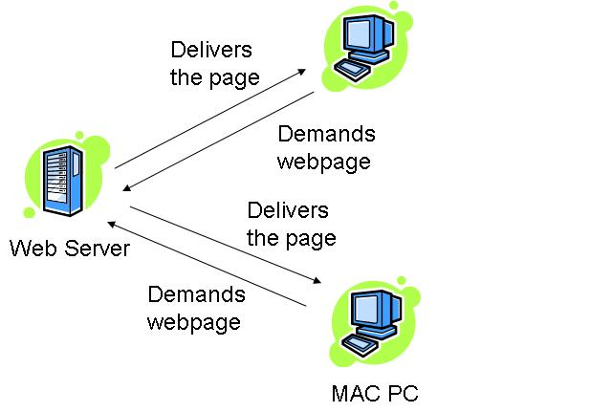(wikibooks.org, 2018)

* **Displaying** – The webpages would be displayed on the client’s device as they are requested from server.

### **Information Technology to be utilized**

* Visual studio Code or VS Code is a code editor by Microsoft. The visual studio code was chosen because it provides useful features such as auto-competition, cross platform, integrated debugger, inbuilt terminal, live server, customization and huge library of plugins available. VS Code is also having an embedded git control and has great and fast performance comparing to other editors like atom or sublime text. Visual studio code is an essential tool when developing a website.
* Hypertext markup languageor also known as HTML5is the programming language which is going to be used in developing a structure of the webpages.
* Cascading Style Sheets or also known as CSS is the programming language which is used to add style to the HTML5 language. For example, setting up the font family of the text in certain containers.
* JavaScript or also known as JS is the programming language which gives ability to create dynamic responsive websites. For example, dynamically updating data and animations.
* JavaScript Object Notation or JSON is the data format that uses human readable text.
* Internet is going to be used to display the website, research and hosting the website.
* For this project have been used two computer, laptop and desktop computer.
  + **Laptop – ASUS GL752VL**
    - CPU: i7 6700HQ base speed: 2.59 GHz, 4 cores, 8 threads
    - Integrated graphics: Intel® HD Graphics 530
    - Graphics Card: GTX 965M 4GB
    - RAM: 8GB DDR4 2400
    - Storage 1: 128gb m.2 2280 SSD
    - Storage 2: 1TB Toshiba HDD
    - OS: Windows 10
    - This laptop provides enough computer power for this project. However, under heavy load it would thermal throttle and its not suitable for rendering.
  + **Desktop** 
    - Motherboard: ASUS Maximus VII Ranger
    - CPU: i7 4770k base speed: 3.50GHz, Overclocked to 4.20GHz, 4 cores, 8 threads
    - CPU cooler: Alphacool CPU water block with 360mm radiator
    - Graphics card: ASUS Strix GTX 970 DC2OC 4GD5, overclocked
    - RAM: 16gb DRR3 2333
    - Storage 1: 128GB 2.5” SSD (Windows 10 OS)
    - Storage 2: 1TB WD Blue 3.5” HDD
    - Storage 3: 1TB WD Green 3.5” HDD
    - Storage 4: 1TB WD Black 3.5” HDD
    - Storage 5: 640GB WD Blue 2.5” HDD (Linux Ubuntu 18.04LTS OS)
    - OS: Windows 10, Linux Ubuntu 18.04LTS
    - This desktop runs two different operating systems, windows 10 pro and linux ubuntu 18.04LTS which gives advantage of using a specific operating system for specific task such as ubuntu 18.04LTS would be for development and windows 10 would be more digital media aspect. I have used ubuntu as my main operating system because it provides a better command-line control over a system and customization. In this computer, CPU and graphics card has been overclocked to allow me to use the full potentials of the hardware in this computer. This computer has enough computer power and storage.

### **Ethical and Social Issues**

**Individual**

* Copyright is the law which gives exclusive rights to a work by its creator. This allows the creator to reproduce the work over a fixed period of time and prevents anyone else from using the concept of the original idea. This is important in website development to protect the ‘owner’ from anyone copying and using the website as their own. My website will be an open sourced project under MIT licence, which means that persons using the website must acknowledge the original website and its owner.

* Ergonomics is important during the development of the website. The following aspects must be considered during the website development:
  + A proper keyboard which is able to prevent typing injuries or aggravating injuries such as carpal tunnel syndrome in anyone working for a long period of time.
  + A proper mouse must be used when working at a computer for long periods of time.
  + Proper lighting which involves the appropriate level of lighting and its location while the user at the computer.
  + A proper working chair is vital to the health of a person who is working long hours on the computer.
* Overworking results in poor productivity and lower quality of work. The best approach to good website development involves planning and time management of work. Repetitive Strain Injury can result from overworking (working long hours) and poor ergonomics of the workspace.
* Plagiarism must be avoided at all costs and is a serious violation of ethics in all creative work and written expression. All the work of other people that is used in the development of the website and digital media must be acknowledged and documented.

**End-User**

* All data and information on the website must be accurate and reliable.
* Aesthetics is an important aspect of the website’s design. Generally, it must have appropriate visual appeal, be well laid out and there should be no visual distractions which take away from the user’s ability to use the website. Clear navigation is vital is the use of the website and can be enhanced by good aesthetics. The entire website must be age appropriate and effective for all end users.

## Making Decisions

### Schedule Feasibility

|  |  |  |  |  |  |  |  |  |  |  |  |  |  |
| --- | --- | --- | --- | --- | --- | --- | --- | --- | --- | --- | --- | --- | --- |
|  | | Term 2 | | | | | | | Holidays | | | Term 3 | |
| W3 | W4 | W5 | W6 | W7 | W8 | W9 | W1 | W2 | W3 | W1 | W2 |
| Understanding the Problem | A requirement report |  |  |  |  |  |  |  |  |  |  |  |  |
| Social and ethical issues |  |  |  |  |  |  |  |  |  |  |  |  |
| Making Decisions | Schedule Feasibility |  |  |  |  |  |  |  |  |  |  |  |  |
| Designing solutions | Design of the website |  |  |  |  |  |  |  |  |  |  |  |  |
| Design of the digital media |  |  |  |  |  |  |  |  |  |  |  |  |
| Implementing | Implementing evidence of the website |  |  |  |  |  |  |  |  |  |  |  |  |
| Implementing evidence of the wow goal |  |  |  |  |  |  |  |  |  |  |  |  |
| Testing, maintenance, evaluation | Testing Tables |  |  |  |  |  |  |  |  |  |  |  |  |
| Reflection |  |  |  |  |  |  |  |  |  |  |  |  |
| Future maintenance |  |  |  |  |  |  |  |  |  |  |  |  |
| Source Table |  |  |  |  |  |  |  |  |  |  |  |  |

### Sched

## Justification of the Gantt Chart

### Understanding the problem

**A requirement report** – In a requirement report section we had to understand the problem and the objectives of the website. We were required to understand how the website would help to meet Pittwater house’s goals. Data and information which would be used, must be identified before designing the website and digital media. The seven information processes were understood and identified of the website’s environment. The different information technologies were researched and chosen to be used in the website. The requirement report would take to complete from week 3 to week 5 of term 2.

**Social and ethical issues** – For the social and ethical issues section, the different laws and issues were identified such as copyright law, ergonomics, accuracy and relevance of the information to the topic, overworking and security. This section would take 2 weeks to complete starting from week 5 to week 6 of term 2.

### Making Decisions

**Schedule feasibility** – Schedule feasibility is the section where we were required to plan our project and have to be tabulated it in Gantt Chart. Schedule feasibility should not take long time to complete therefore, one week is allocated for completion of the schedule feasibility.

### Designing solutions

**Design of the website** – For designing of the website were allocated 3 weeks so that any changes can be made to the design.

**Design of the digital media** – for the design of the digital media were allocated 3 weeks after the design of the website, so that digital media would be in the same theme as the website.

### Implementing

**Implementing evidence of the website** – The implementing evidence of the website would take the longest to complete because it is including the development of the website and documentation which would take large amount of time. Therefore, almost 11 weeks were allocated, starting from week 4 of term 2 and ends on week 2 of term 3.

**Implementing evidence of the wow goal** - The implementing evidence of the wow goal would take fair amount of time because it requires to learn new skills and apply them those skills in the development of the website. The minimum requirement for wow goal is to learn new skills for at least for 9 hours. Therefore, 6 weeks were allocated for completion this section.

### Testing

**Testing Tables** – For the testing tables have been were allocated nearly 11 weeks because when you are developing a website or digital media you always something testing and that have to be recorded.

**Reflection** – For the reflection section have been allocated last 2 weeks of the project because it requires evaluation and reflection of the final project.

**Future maintenance** – For the future maintenance have been allocated last 2 weeks of the project because it requires to determine what maintenance have to be done in future.

**Source table** – Time for the source table is the duration of the project because researching is going to be throughout the project and have to be logged in source table.

## Designing Solutions

### Designs and storyboard for the website

Design of index.html

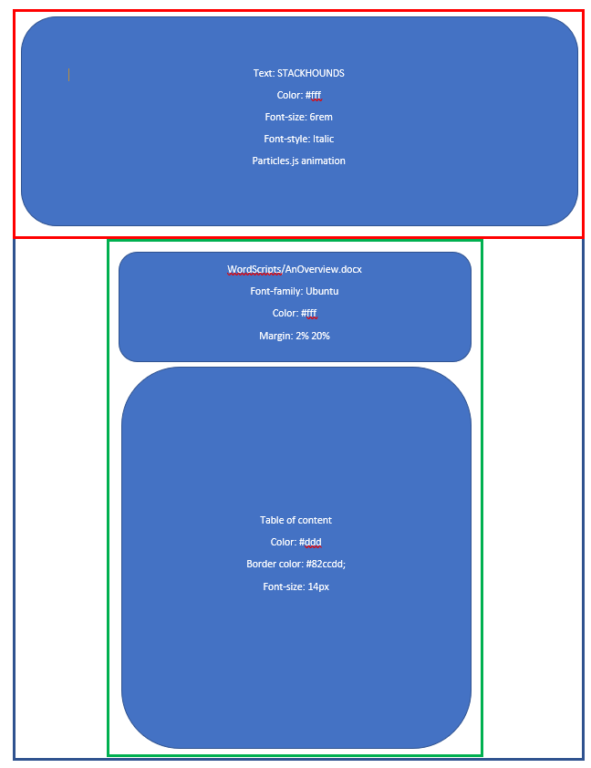

Design of the BasicFeatures.html

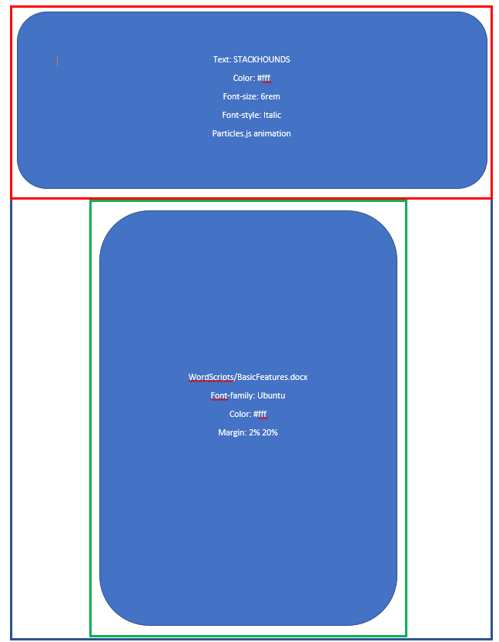

Design of the Electronic Email 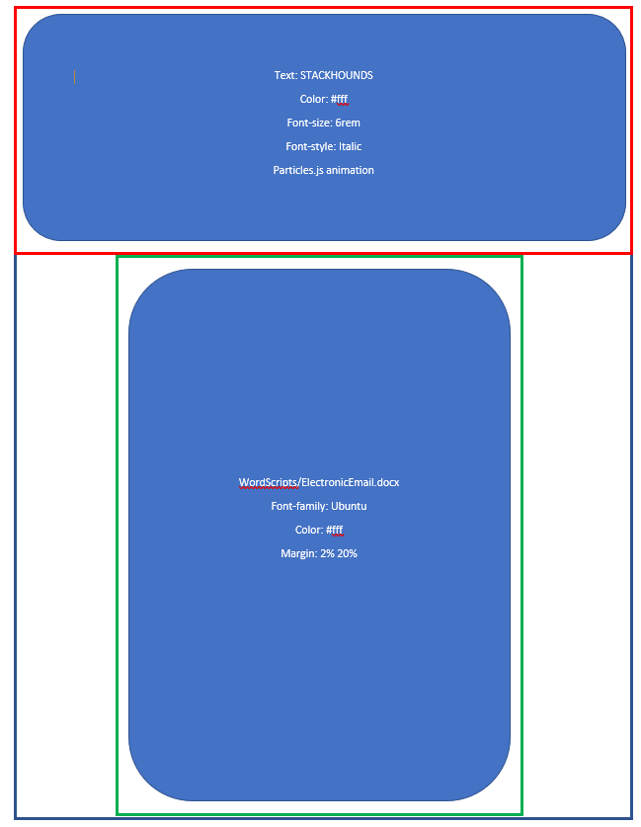

Design of the Internet Publishing

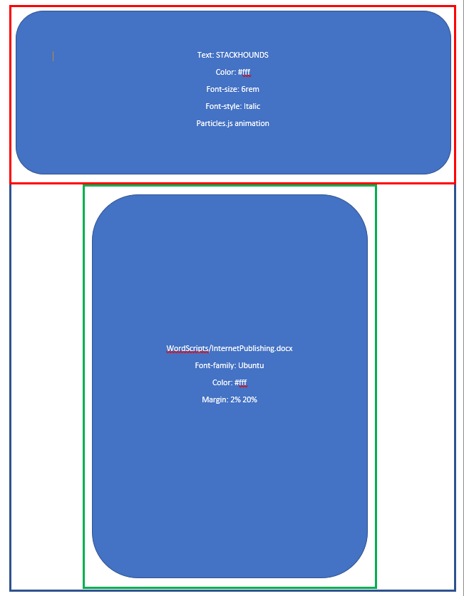

**Structure of the webpages**

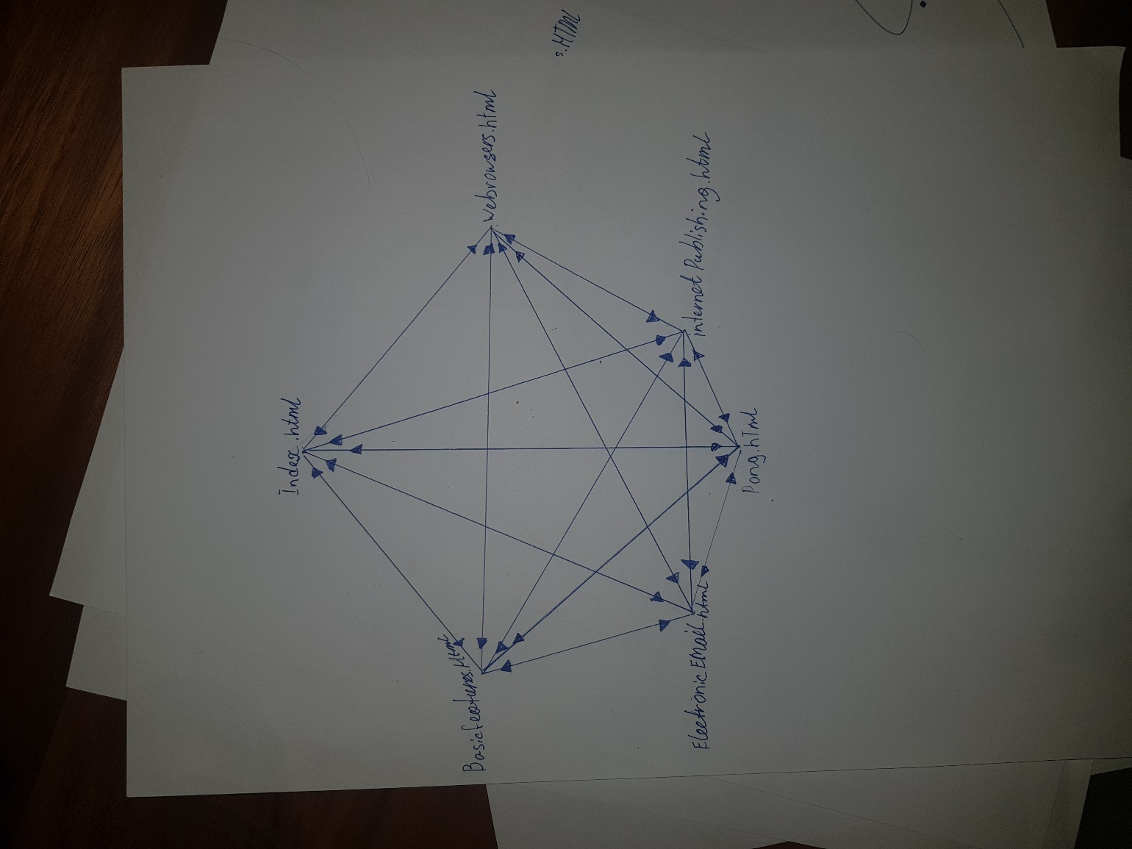

### Designs and storyboard for the digital media

**Particles Animation**

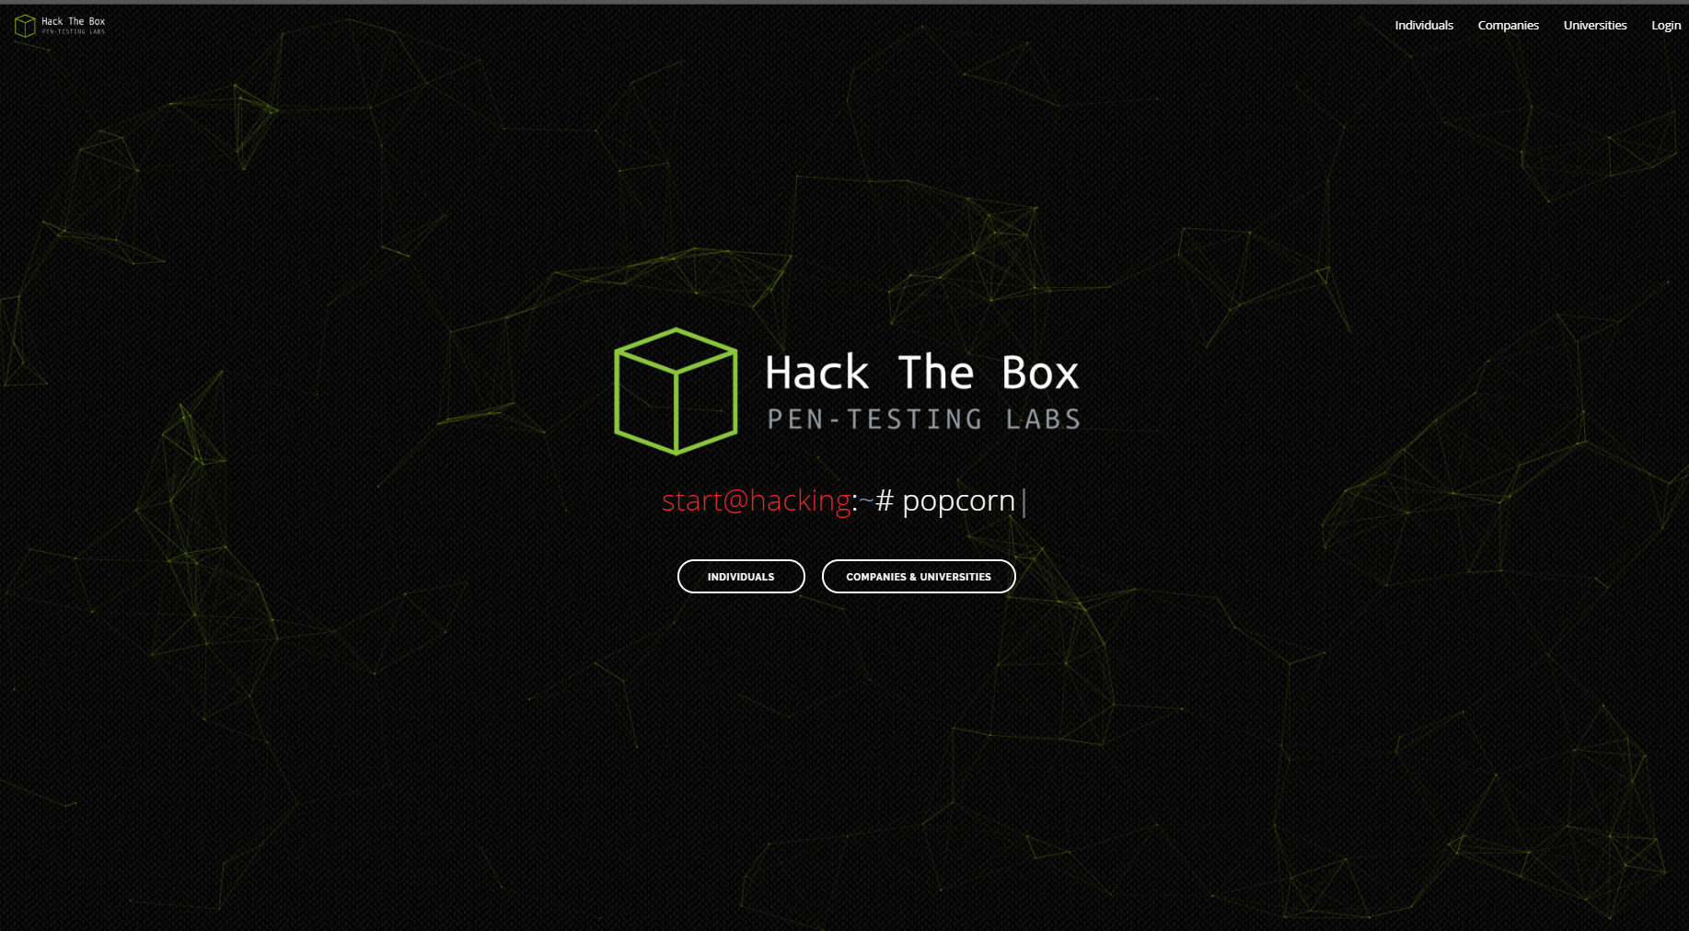

For the particles animation I got inspired from hackthebox.eu. For my website I want to make something like this but different colors. Color I’m going to use for particles is #99a4b2 and make less particles because it can take a while to load, and CPU and RAM would be heavily used while the particle animation is rendering.

**On hover animation**

 

**Poster**

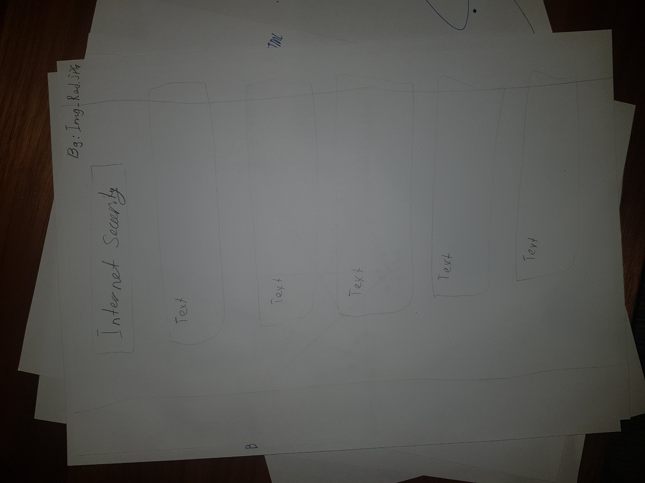

## Implementing

### Implementation of Website

|  |  |  |  |
| --- | --- | --- | --- |
| Website Development logbook | | | |
| Date | **Duration** | **Target** | **Achieved** |
| 5/22/2019 | 1h | To create a background particle using particle.js library | yes |
| 5/22/2019 | 1h | To experiment and configure particles. json | yes |
| 5/23/2019 | 1h | To create a side bar navigation | yes |
| 5/242019 | 1h | To create a dropdown menu in a side bar navigation | Yes |
| 5/24/2019 | 1.5 | To style a dropdown menu + sidebar and create container | Yes |
| 6/1/2019 | 3h | To finish home page | No |
| 6/3/2019 | 0.5h | To finish home page by configuring icons for summary and make a footer | yes |
| 6/4/2019 | 1h | To layout the BasicFeatures.html | yes |
| 6/6/2019 | 0.5h | To format the review the code and format it | yes |
| 6/19/2019 | 1h | To finish the basicfeatures.html file | Yes |
| 6/20/2019 | 1h | To create a webbrowsers.html and create a basic structure | yes |
| 7/30/2019 | 0.5h | To finish webbrowsers.html | yes |
| 7/30/19 | 0.5h | To create and finish electronicEmail.html | Yes |
| 7/30/19 | 0.5h | To create and finish internetPublishing.html | yes |

Explanation of the code from style.css

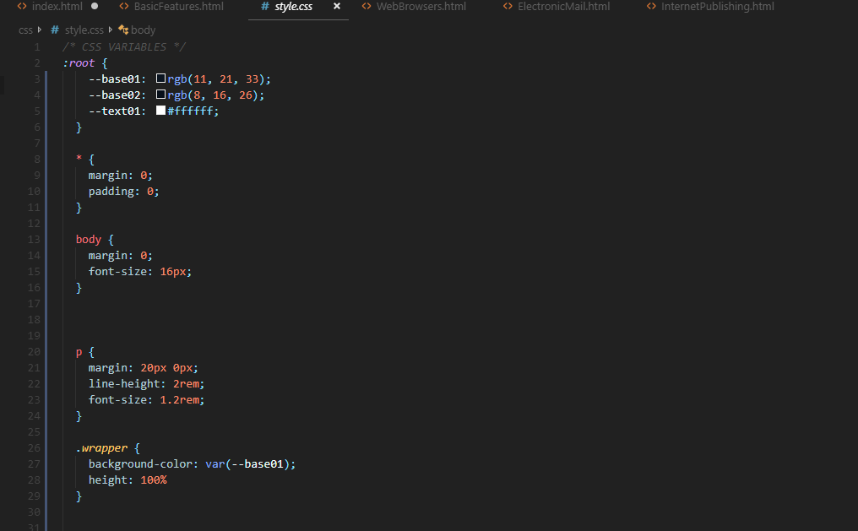

|  |  |
| --- | --- |
| Line 2-5 | Creating global variables using :root to set it to global. The syntax of the variable is: --name: command; |
| Line 13-15 | Setting margin to 0 and font-size at 16px for body |
| Line 20-24 | Setting margin 20px top and bottom, 0px left and right, line-height at 2rem and font-size: 1.2rem. |
| Line 26-29 | Creating a class named wrapper and setting background color to to –base01 or rgb(11, 21, 33). |

### Implementation of Wow Factor

|  |  |  |  |
| --- | --- | --- | --- |
| WOW Goal Logbook | | | |
| Date | **Duration** | **Target** | **Achieved** |
| 5/22/2019 | 2h | To use a JavaScript library for particles effects and to use JSON file for the settings of the effect | Yes |
| 7/30/2019 | 1h | To create a loading screen | No, I have made the animation but didn’t find a way to make it a loading screen that I disappears after everything is loaded. |
| 7/19/2019 | 3h | To create a pong game using p5js library | Yes |
| 7/28/2019 | 3h | To create poster using inDesign | yes |

## Testing, Evaluating and Maintenance

### Testing

Testing Table

|  |  |  |  |  |
| --- | --- | --- | --- | --- |
| Test Number | Test Name | Expected outcome | Actual Outcome | Changes made |
| 1 | Custom fonts | Custom font is imported | Custom font is imported | n/a |
| 2 | Changing font size using 1.2 rem units | Font size would be increased by 1.2 rem | Font size would be increased by 1.2 rem | n/a |
| 3 | Creating a root variable in css | Defined variable for color which can be used globally in css file | Defined variable for color which can be used globally in css file | n/a |
| 4 | Particles.json – increasing value number | Setting value number of particles to 50 | 50 particles were rendered. | Number of particles has been reduced to 20 due to 50 particles were lag on website. |
| 5 | Importing custom AwesomeFont icons | By adding Awesomefont database to my website so I am able to use custom icons in my HTML and apply custom settings on them through CSS | The icons have been successfully and color has been changed from black to light blue | n/a |
| 6 | sliding side bar | Using JS create sliding side bar menu | Sliding side bar was been created and worked. | n/a |
| 7 | Dropdown menu | Dropdown menu would be added to the side bar | Dropdown has been added to the side bar. | On hover effect has been added |

**Peer review for BasicFeatures.html**

|  |  |  |  |
| --- | --- | --- | --- |
| Question | Feedback | Suggested areas for improvement | Changes made |
| Is the webpage aesthetic pleasant? | The webpage is aesthetically pleasant. | Add a bit more colors | No changes have been made because it would change the color scheme of the website. |
| Is it easy to read the content on the page? | The content on the page is easy to read and concise. | A use of videos and pictures | No changes were made to this webpage. However, the next webpages would include videos and pictures |
| Is navigation to the other pages clear? | Navigation is clear and easy to use | n/a | n/a |

**Peer review for particles.js**

|  |  |  |  |
| --- | --- | --- | --- |
| Question | Feedback | Suggested areas for improvement | Changes made |
| Do you like the particle effect | I do like the particle effect, especially how it gives a special feature to a website. | I would increase the number of the particles | No changes were made because if I increase the number of particles, the lag would occur on the website. |

### Reflection

I feel like my project was successful. The main objective of the website was to educate Year 11 IPT students about the internet. My website uses text to explain the concept aswell as plenty of videos are provided to enhance the understanding of the concept. My website has simple design and easily understandable concept. The navigation menu is clear and easy to use to navigation through webpages. The website is appropriate for all ages throughout grade 7 to 12.

### Future maintenance

* The content on the website must be update to the newer technologies and to syllabus.
* The website’s domain has to purchase as well as HTTPS certificated
* The content on the website might be expanding in future
* For my website I have used several embedded YouTube, the links overtime can break. The links have to maintained.

Instructions to run the website:

1. Open text editor
   1. Atom:
      1. Go to settings > install > search package “live server” > install atom-live-server
      2. Open index.html
      3. CTRL + SHIFT + P > type “server” > start “Atom Live Server: start xxxx”
   2. Visual Studio Code
      1. Go to extensions > search “liver server” > install “live server”
      2. Open index.html
      3. Right click on the code area and click on “Open with live server”

GitHub:

<https://github.com/dogs1388/FSNZ>

Website Link:

[http://stackhounds.epizy.com](http://stackhounds.epizy.com/)

Photos:

Index.html:



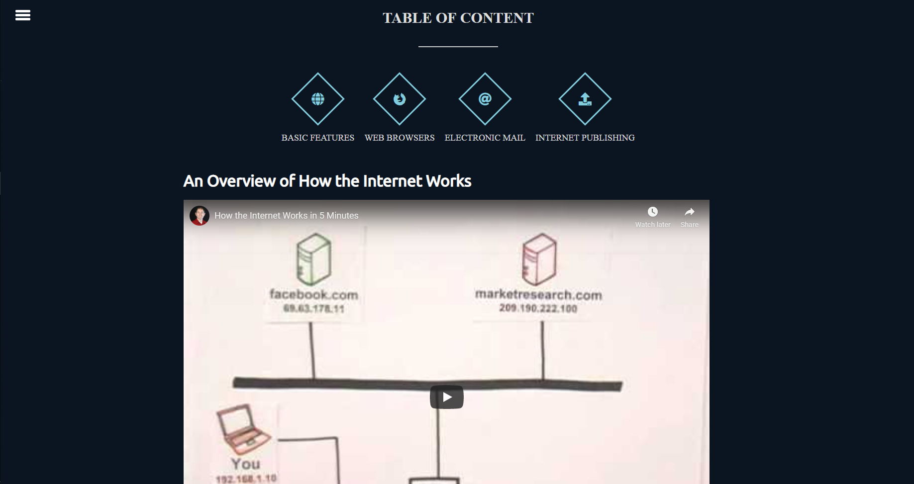

BasicFeatures.html

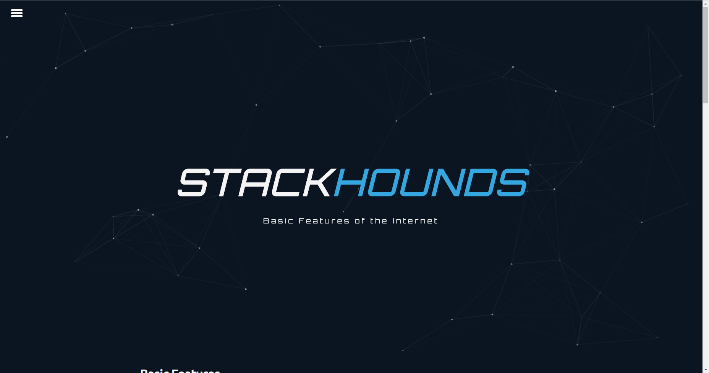

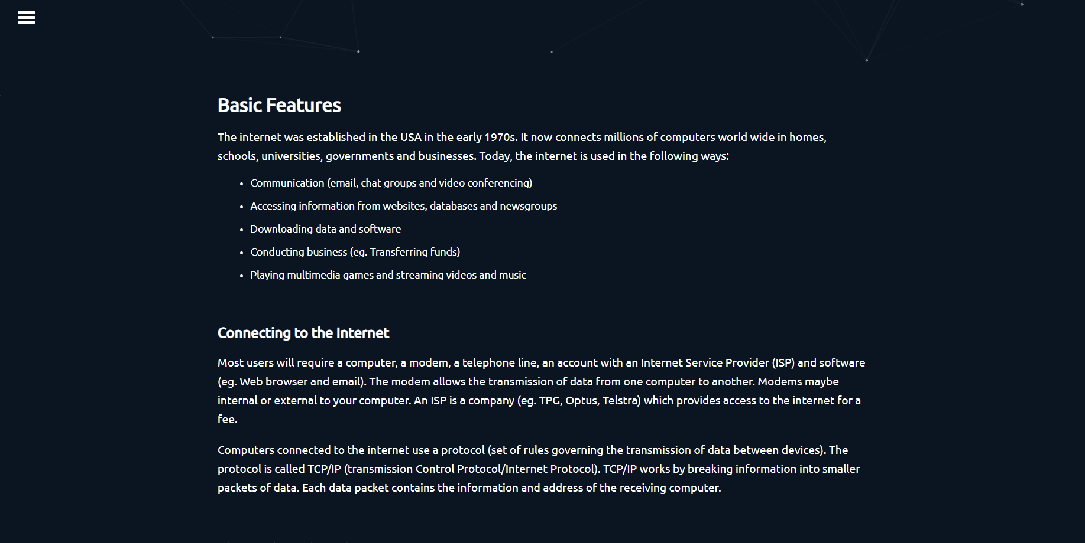

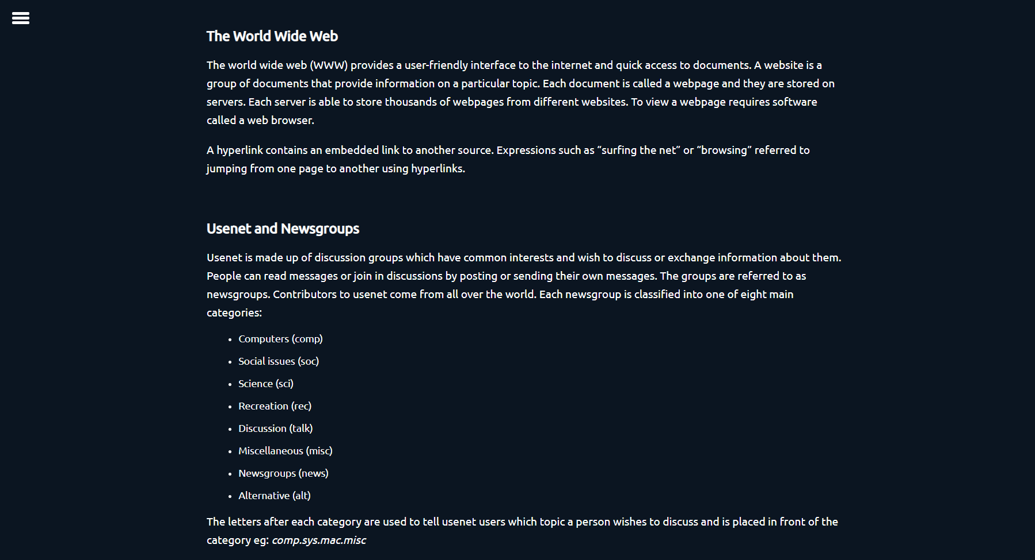

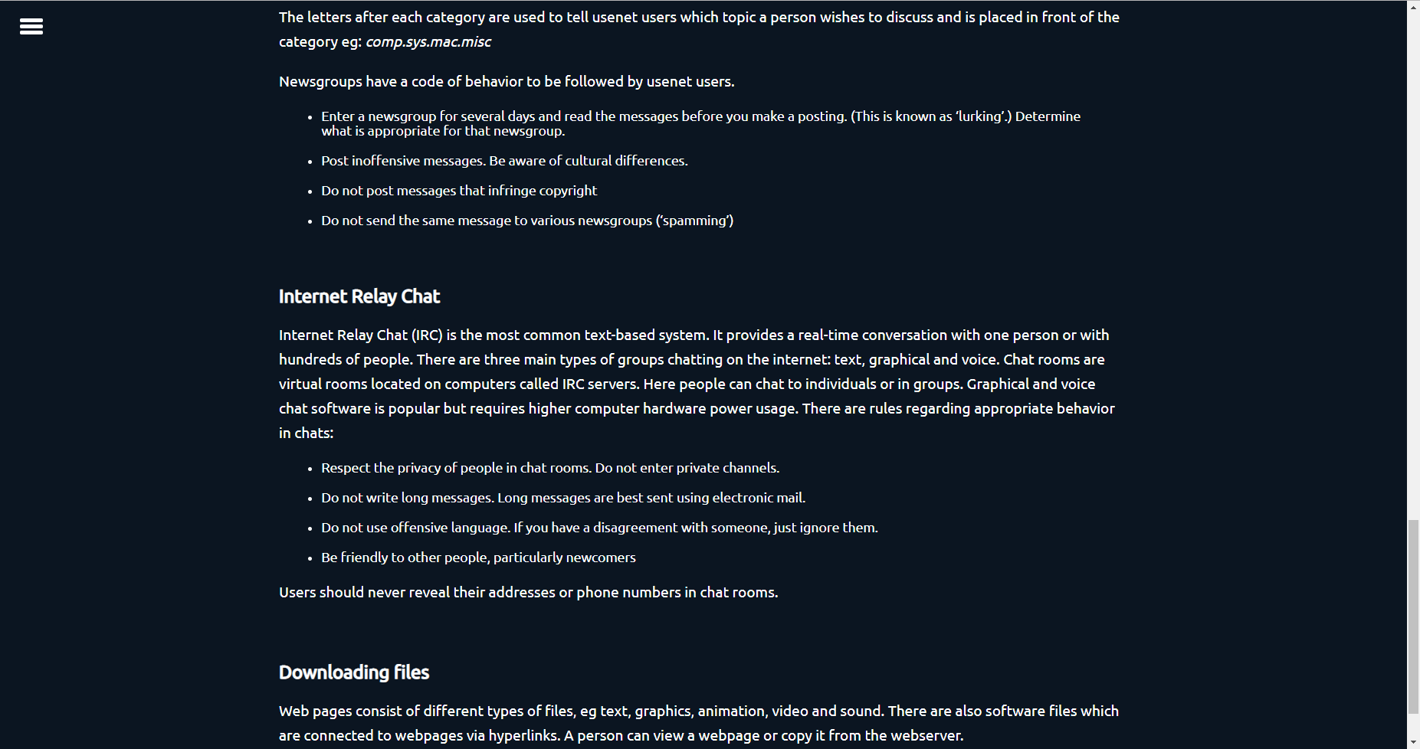

ElectronicEmail.html



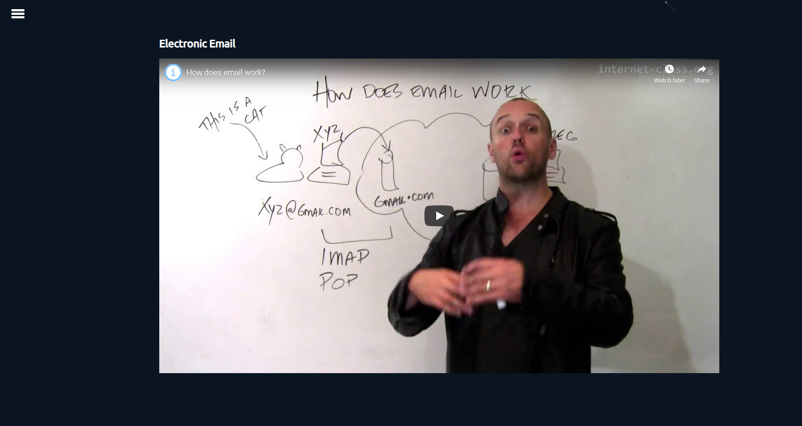

Internet Publishing



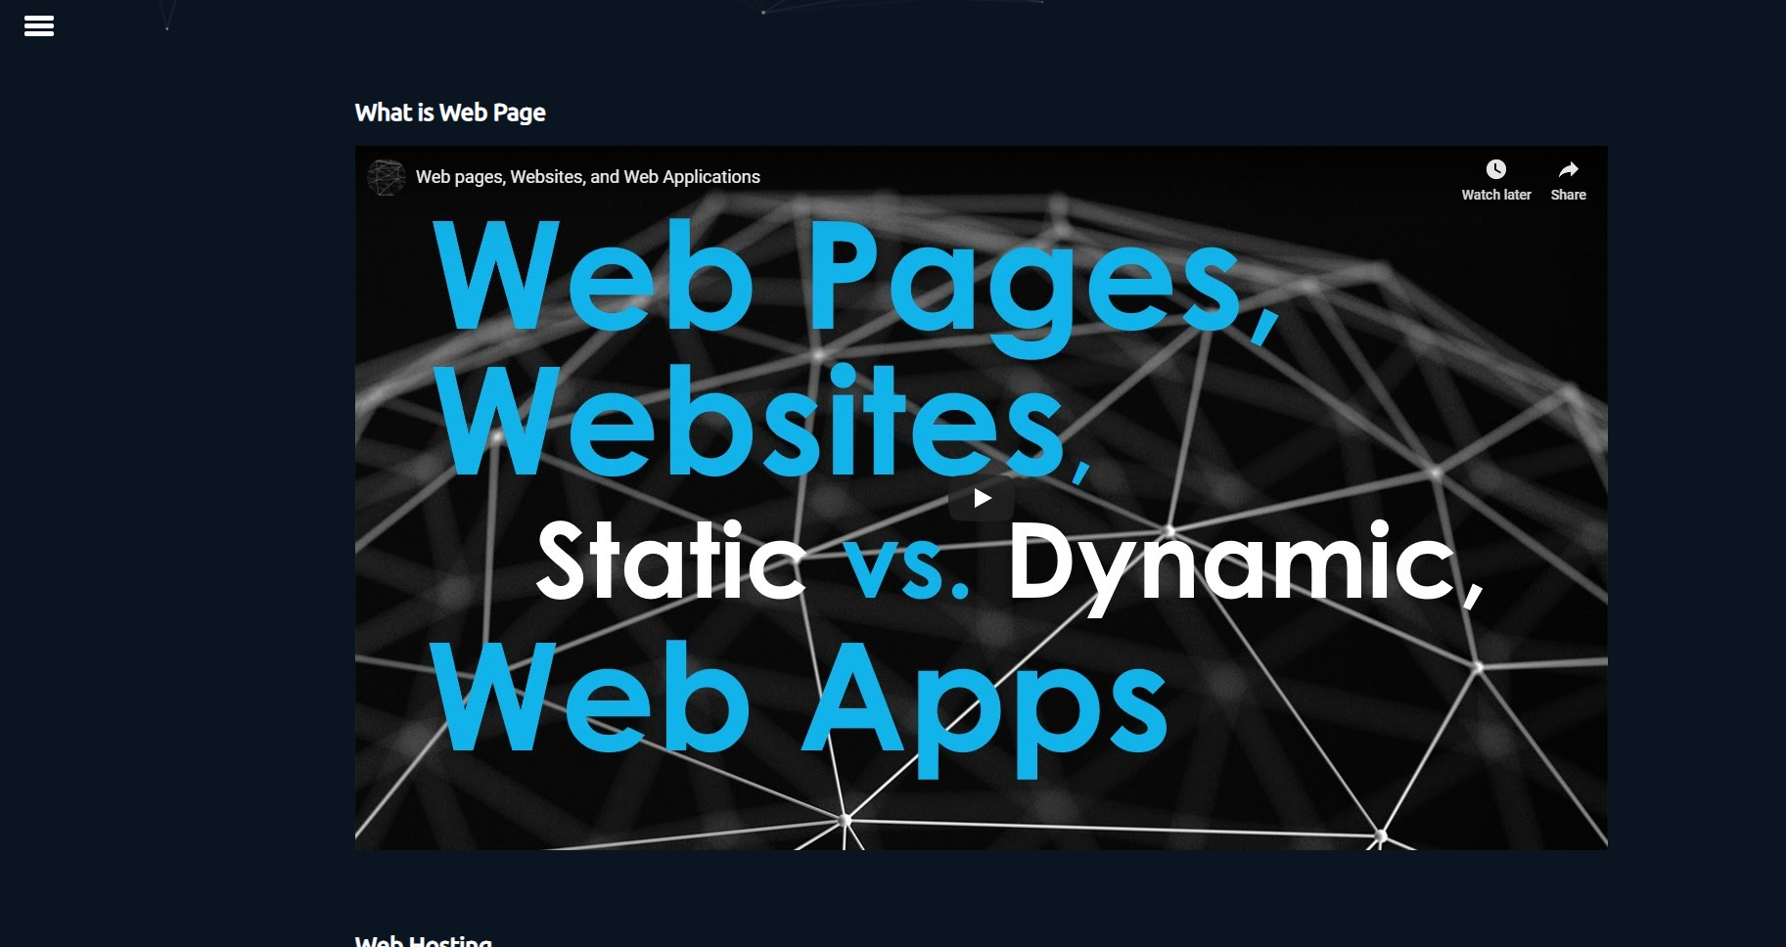

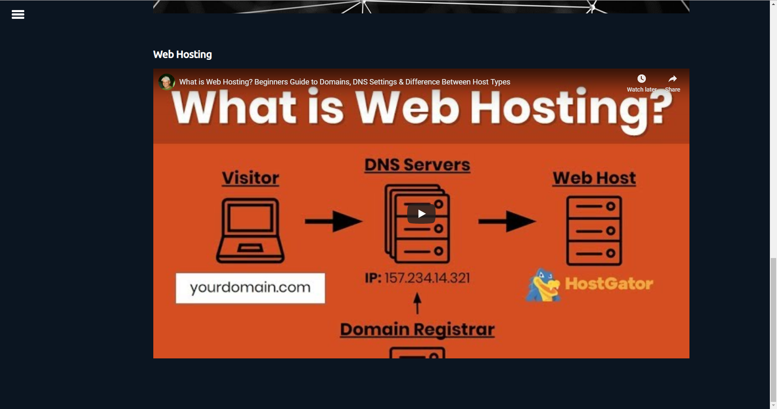

Poster

